Tuolumne River Technical Advisory Committee
Don Pedro Project - FERC License 2299

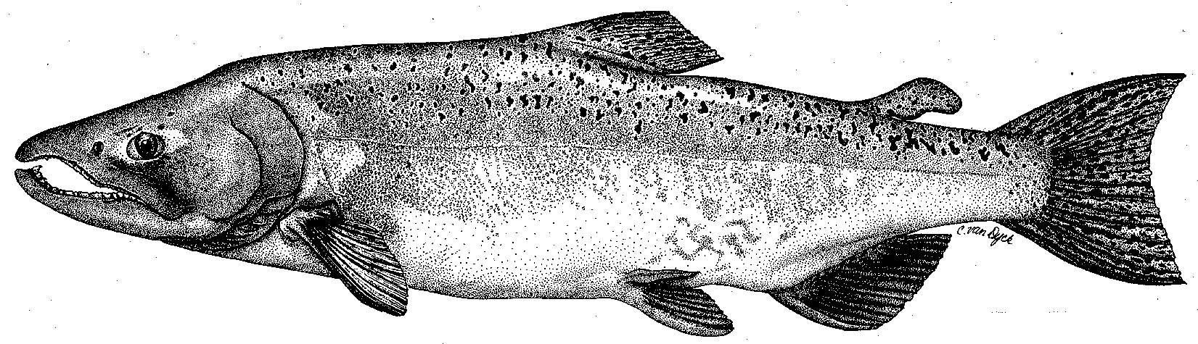

Modesto Irrigation District
Turlock Irrigation District
City & County of San Francisco
California Department of Fish & Wildlife
U. S. Fish & Wildlife Service
333 East Canal Drive
Turlock, CA 95381-0949
Phone: (209) 883-8278
Fax: (209) 656-2191
Email: pemaloney@tid.org

TECHNICAL ADVISORY COMMITTEE MEETING
08 December 2016 at 9:30 AM
Turlock Irrigation District, Room 152

DRAFT AGENDA

1. Introduction and Announcements

2. Administrative Items:

Review/revise agenda

Approve notes from Sep 2016 meeting

Items since last meeting

3. Monitoring/Reports:
- Fall run information – status of weir and red surveys
- Other technical reports for 2016 annual FERC report
- Discuss winter temperature monitoring / logger issues
- Discuss La Grange Fish Passage Study

4. Flow Operations:
- Review status of flow schedule/watershed conditions

5. Agency/NGO updates

6. Additional items

7. Next meeting Date: March 09, 2017

